
brojed@aol.com
brojed.org
cell:573-999-0347
573-999-0347

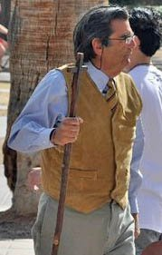
Martha Marie, Bro. Jed and Evangeline:
A Week at the University of Arizona

Note from Sis. Cindy:
Dear all,
Below is Bro. Jed's report and pictures from last week at the University of Arizona in Tucson. It was an exciting and fruitful week as they were joined by Evangeline for four days...
To give you an update on Arizona State... At this point the stolen staff has not been returned. Yesterday another student attempted to steal Bro. Jed's Bible but Martha grabbed the guy and got the Bible back. Pray for their protection as they preach two more days at ASU and then on to California.

MORE VILE
UA, February 14, 2011
Since it was Valentine’s Day, I started off by teaching on the nature of love. Too many see Jesus as some sort of Cupid shooting little love arrows. Eros is the Greek equivalent of the Roman figure Cupid. Christians speak of agape, which they usually define as unconditional love but it should be understood as self-sacrificing love. Cupid and Eros are associated with the gratification of carnal desires.
Soon a woman and a transsexual pervert approached the hill selling chocolate penises and vaginas. The students thought this was quite funny. They were raising money for the Gay Alliance, which has been sponsoring the protest by white winged angels.

Selling Candy Penises and Vaginas
My mind was still on the home fellowship meeting which I spoke at yesterday, hosted by very old friends of the ministry going back to my Indiana days. A Baptist pastor, who attended the fellowship meeting on the recommendation of my friends, had invited me to speak in his church but then disinvited me when he found out my beliefs on open theism. Friday the pastor came out to campus to check out my ministry since he had been shocked by my “profane” presentations which he had seen on youtube. Students like to post on youtube my more sensational material such as the gay song, my use of electrical cords to demonstrate normal and abnormal sexual relations, etc.
As people were arriving for yesterday’s home meeting, I asked the pastor what he thought of the campus preaching (knowing that he did not like it). He said, “I wanted to see you in person, hoping the vulgar reference to male and female anatomy were not the norm. I was sorely disappointed. In fact, you used language describing the creative acts that I found repulsive. . . I have on very rare occasions heard construction workers with the most rudimentary of educations resort to such vile word pictures to make their point. I am not surprised to hear lost people talk and act in such a manner, but to hear a man who is so well educated and who professes to be a Christian do is embarrassing, appalling, and disappointing.”
I did not want to become overly defensive and get into a big argument since it could detract from my prepared words. I give the Pastor credit for at least coming to campus and to the home meeting to hear me out. I also realize that he was not familiar with the current university scene.
Martha, seeing her dad under attack, was stirred to my defense. She reminded the pastor of David dancing before the Lord girded only with a linen ephod. Michal objected and chastised David saying, “How glorious was the king of Israel to day, who uncovered himself to day in the eyes of the handmaids of his servants, as one of the vain fellows shamelessly uncovereth himself!” David’s response was, “I play before the LORD. And I will yet be more vile than thus, and will be more base in mine own sight.”—2 Samuel 6.
Martha did not think that the pastor really listened to her as he continued to chastise me. He particularly objected to my telling the girls, who are so obsessed with the size of their breasts, that if they would find a husband and get pregnant they could have bigger boobs.
I explained to the pastor that I am teasing the students and using satire to demonstrate the sin and shamefulness of their obsession on physical gratification.
Even after I gave my sermon on the four basic questions, the pastor was still disturbed and there was a lady who had also seen the youtube videos who strongly objected to my singing of the gay song. Today I discovered that our discussion was going on at the time when Lady Gaga was singing a song at the Grammy Awards which included the following lyrics,
REJOICE AND LOVE YOURSELF TODAY
'CAUSE BABY YOU WERE BORN THIS WAY
NO MATTER GAY, STRAIGHT, OR BI,
LESBIAN, TRANSGENDERED LIFE
I'M ON THE RIGHT TRACK BABY
I WAS BORN TO SURVIVE
NO MATTER BLACK, WHITE OR BEIGE
CHOLA OR ORIENT MADE
I'M ON THE RIGHT TRACK BABY
I WAS BORN TO BE BRAVE
Yet the Christian lady objected to my singing, “It’s not OK to be gay!” Does she not know what youth are hearing today? Lady Gaga has become a role model for many college girls. The Christian lady claimed that I am demeaning myself. I agreed that I am humiliating myself. So did Jesus by taking on “sinful flesh.” It is unfortunate that I have to be so outrageous at times to illustrate the folly of sin. Too bad I cannot always take more intellectual approach.
I was thinking of the events of yesterday while I listened to the perverts promoting their chocolate genitalia. I became not so angry with the perverts, but mad at the Christians who objected to my vulgarity, but will not stand against the gross sin of the day. I determined that I was going to be viler today.

Students gather on the grassy hill to hear the preaching.
An atheist wearing a t-shirt which read “Godless,” kept asking me how can God know everything and man have a free will. I explained that God does not know our future moral choices. The Episcopal priest who comes out almost every day stood beside me and tried to reconcile free will and predestination. When the priest heard my teachings concerning open theism, he had a hissy. Interestedly, he accused me of the same thing that the Baptist pastor had done in a letter he wrote me, “teaching which undermine the sovereignty of God or doctrine that diminishes His omniscience cannot be overlooked. I believe that God’s sovereignty is absolute and his omniscience is just that, omniscient. To believe otherwise is to weaken the very meaning of the name, God.”
The priest accused me of departing with 20 centuries of Christian teaching. Then Roy Spears chastened him for his hypocrisy by departing from historical Christian teaching by being a homosexual. I did not know that the priest was a homosexual. I had been treating him with some respect since he did indicate faith in the atoning death and bodily resurrection. The priest needs to hear the gay song. Yet the Christian lady thinks I am the one demeaning the testimony of Christ.
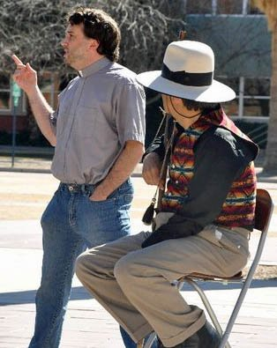
Homosexual Priest Objects to Preaching
The atheist asked me why Jesus had to die on the cross. The priest could not answer his question; he merely kept referring to what Jesus did. I explained why our Lord went to the cross.
The angels did not show up today. The size of the crowd was about half of what it was daily last week. The students were mostly attentive and generally civil. We had some in depth discussions. Roy had a group around him for most of the day.
The Skeptics Club brought out their bingo cards and the students enjoyed playing the game. The Christian lady had also seen the bingo on youtube videos. She perceived “Brother Jed Bingo” as evidence that I must not be preaching the word and that students are not paying any attention or they would not be playing bingo. The cards have words which I frequently use such as The Devil, Porn, Justice, Filled with the Spirit, Natural Law, and the First Cause. The cards also include some of the sexual or anatomical terms which I use such as Breasts, Erection, Cleavage, Squirt, Testicles, Orgasm, and Penis. Martha explained that these cards make the students concentrate more on what I am saying. I explained to her that I was also adding to their vocabulary because some of these words or phrases are not a part of the university curriculum.

"The Skeptics Club brought out their bingo cards and the students enjoyed playing the game."

About 4:30 when the size of the crowd was down to about 20, Mike, who had been sitting and praying off at a distance, came over. I was happy to let him take over. There was a boy who had been in my face last week but seemed to have somewhat of an attitude change today. He said one of his parents was a Baptist and the other a Catholic. Mike began to answer some of his questions. I took a break, and Martha and I left campus shortly after 5 PM. Mike called me later. He was excited that the boy from the Baptist Catholic family followed him to the parking garage and he allowed Mike to pray for him.
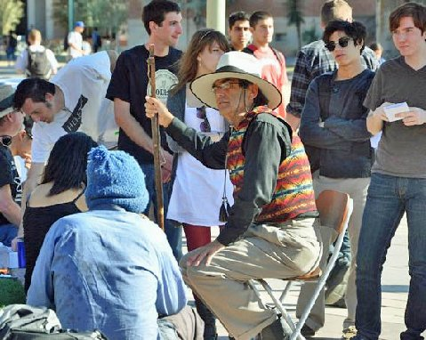
Martha did her HPV Holly story today. She did her main work yesterday. The confrontation with those who oppose me yesterday gave Martha an opportunity to boldly defend our ministry. I liked that. Today, she spent some time visiting with a local home school mom, who heard me 30 years ago on campus. She came to campus today to listen to me once again after all these years.

Notice the girls in the background!
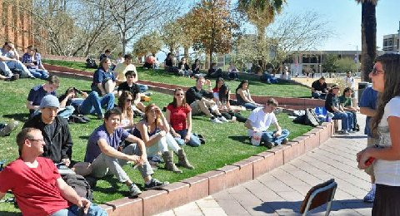
Martha ministers at UA
EVANGELINE RETURNS TO THE BATTLEFIELD

UA, February 15, 2011
I started off reading the curses from Deut. 28 for disobeying the voice of God and rejecting his commandments. This is a long list so it took some time as I applied the curses to current affairs. Many of the students were playing Brother Jed Bingo as I expounded on the curses.
Then I read from Lev 18 which lists a variety of sexual sins. Finally, I gave my testimony which contains a lot of the words on their bingo cards. They were quite attentive during my testimony.
I called upon Evangeline who flew into Tucson to join us until she flies back to MO on Saturday night. Except for a brief appearance on campus during an SOE she has not been on campus for nine years. Martha and I were excited that she was back in action.
Evangeline spoke on the Army values; she addressed loyalty, duty and respect. None of these are values promoted on campus, unless it would be loyalty to the sports teams. She held the attention of the students well.
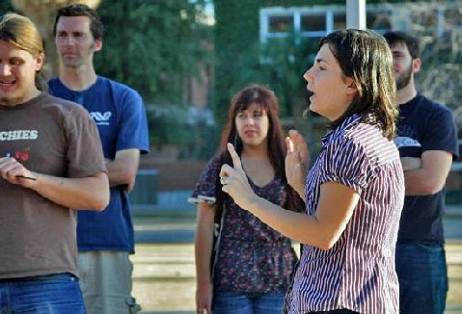
"...Evangeline spoke on the Army values..."
The students were not inclined to engage me today. Perhaps it was too hot. The sun and heat was sapping me of some of my energy. Along about 3:30 I asked Mike to speak. He is on oxygen because of a rare lung disease which was diagnosed six years ago. He is in line to get a transplant. I appreciate the way each year Mike rises to the occasion to spend the afternoons witnessing to students. Usually he is so exhausted after I leave town that he is bedridden for a period.
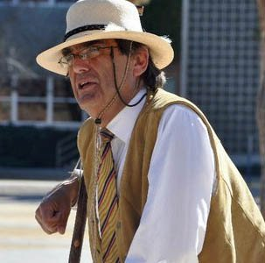
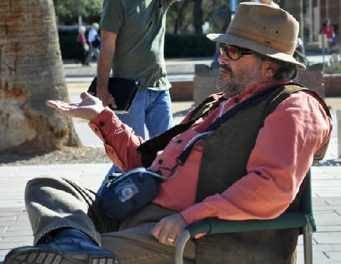
Bro. Mike joins us at UA every year.
After 4 PM I called on Evangeline again and several students became more heated when she preached. As she was preaching I whispered to the students that a transsexual or transvestite was hanging around. The person has been on campus for three decades. Evangeline mostly expounded on the issue of homosexuality.
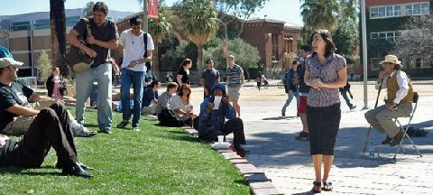
Evangeline

Martha mostly answered questions concerning home schooling. The crowd was smallest on this fifth day on campus ranging from 30-60 for most of the afternoon.

Martha
Amanda, a Jew and graduate of UA, wrote on facebook, “I can't believe I'm missing it again this year. Hearing you talk was the highlight of my whole college experience. That's even what I told them in my On the Spot interview.”

Listeners

ANOTHER DAY AT THE ASYLUM
UA, February 16, 2011
Things livened up again today and the crowds were larger. I opened with an expository message from Romans 1. I explained that I was called to be a special messenger, like Paul, and separated to preach the gospel. God was calling them to be saints and obedient to the faith. Roman 1 tells the causes (vs. 21-28) of homosexuality and describes the 24 Biblical characteristics of a queer (vs. 29-32). I read off the characteristics with all the disgust that I could muster.
Evangeline finished the sermon she started yesterday on the Army Values. Today she spoke of selfless service, honor, integrity and personal courage. She spoke twice today for extended periods of time. Unfortunately, I was usually caught up with answering students’ questions on the sidelines so I did not get to hear much. But what I heard was good. She has not lost the anointing after nine years.


"She has not lost the anointing after nine years."
During her second session someone asked her what she thought about being her husband’s property. She indicated that she had no problem with that; for five years she was the property of the US government. “I could get in trouble for going to the beach and allowing myself to get sunburned which would inhibit my ability to serve. I was considered responsible for taking care of government property.”
Evangeline still has a military mentality, which I think is good. She took all the Army values seriously. I later expounded on the value of honor. The students have no sense of honor. At least they talk about honor in the military. But I never hear anyone talking about it on campus.
The Episcopal homosexual chaplain was out again today. He had a discussion going with the Hill Society for a few hours. However, when Evangeline preached, several from the society came over to talk to me. One, who is an atheist, told me that his grandfather, who raised him, is a pastor with the Church of God in Christ. He has not told his grandfather that he has rejected the faith. He had a number of good questions and usually responded to my answers with, “That makes sense,” or “That is reasonable.” He was particularly interested in the faith vs. works issue. When I had preached on Romans 1, I expounded on “The just shall live by faith.” I explained that faith is the foundation of Christianity. Works are the building. Faith is never alone; true faith embraces good works. We should not think of faith vs. works. But a faith which produces works of righteous. Faith is intended to reveal “the righteousness of God (vs. 17).” How could that be, if Christians are not living righteously?
After Martha did her Sorority Girl Who Met the Devil Skit, one of the young men from the Hill Society wanted to learn all the devil’s lines so he could do the skit with Martha. He really got into it by getting a white tuxedo jacket to wear. It turned out to be a real hit when Martha and the student did the skit together late in the afternoon.
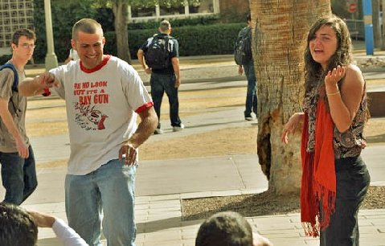

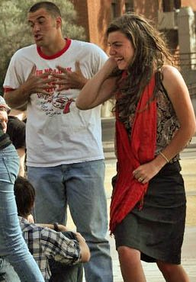
Sceptic Student Plays the Devil in Martha's skit.
One young man, who is a pledge in the Jewish fraternity which the Broken Record is a part, had some good questions. He listened well as I explained how Paradise was lost through the rebellion of Lucifer and the fall of man.
He asked, “Why did God place the fruit of the tree of knowledge of good and evil in the garden?”
I explained, “For the same reason your professor will give you a multiple choice exam which usually has four possible answers but three of them are false. What kind of a test would it be if he only put down the right answer? Professors give true and false exams, but one possible answer is always false. God tested Adam in order to instruct and train him and enable him to develop a holy character because even God cannot create a holy being.”
God will test us even as he tested Job and Abraham to find out what is truly in us. I also expounded on how God proved that Job was an upright man, despite questioning God through his trial Job never turned from God as the devil predicted.
I could tell the Jewish pledge was listening because later when a female asked the same question, he explained my answer to her. He is a relatively mannerly young man. Alas, I fear that he will degenerate like the Broken Record to the animal level after being activated in the fraternity. One of his low life brothers sat beside me quietly harassing for more than an hour. Their model is the depraved and dead, John Belushi.
I know of no students who after graduation from college are more mannerly or honorable than they were when they entered college as a freshman. The few who get converted in college would be the exception. One would think that they would be more cultured after years at a university, but I fear this is rarely the case. There is virtually nothing in college to build the characteristics of a good soldier. Possibly the athletic program might be an exception if they are fortunate to have a good coach, like a Johnnie Wooden.
I had a final good 30 minutes session with about 20 students as I expounded on Jeremiah words, “You shall find God when you seek him with your whole heart.”—29:13.
I closed in prayer as I turned away a few students quietly applauded. I said, “Thank you, I work hard at my craft.”
Hell’s Bells
UA, February 17, 2011
I started a conversation with some students on the hill and talked to them right through a class break. I was so involved in the conversation that I did not notice what Evangeline and Martha referred to as a very large break. I was speaking out against government regulation of the economy. One student agreed with me.
The subject turned to the justice of eternal damnation. I was asked, “How could anyone be happy in Heaven knowing someone they loved was in Hell?”
I answered, “In Heaven we will have a clearer understanding of the sinfulness of sin. We will see how those who outwardly appeared to be nice people, but they were indifferent to God and consequently led many astray by their apathy towards the Truth. The mask of goodness which many wear will be torn away in Hell. In Heaven the righteous will rejoice at the justice of God, even against their damned family members.”
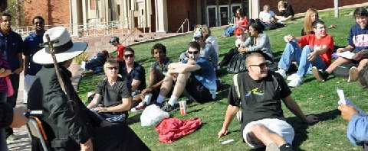
"I started a conversation with some students on the hill and talked
to them right through a class break."
Finally, at 1 PM I started preaching. I had not been speaking long when a fellow holding a music player stood behind me and turned the music up as loudly as he could. This man was filled with the devil. He looked like a street person. Evangeline thought that he was on drugs. The music was openly demonic much of it consisting of screeching. Students were not sympathetic with his rudeness.
After a while I called on Evangeline. Sometimes a change of speakers will help under difficult circumstances. Evangeline was not fazed by the devil’s attempt to keep the students from hearing the Word. Eventually, a fellow wearing a white shirt and tie, who is a regular listener, got between Evangeline and the personification of the devil. That helped the situation. A few students from the Skeptics Club also tried to reason with this devil. After putting up with this for 90 minutes, the devil finally departed. This may have been the worse music that I have ever heard. Since it was difficult to carry on any dialogue with the loud distraction, I entertained the students with a few of the stories that they had been begging me to tell since we have been here but which I have refused to relate.
In Evangeline’s second session homosexuality and original sin were the primary issues. One fellow pleaded hard for original sin reading from Romans 5 claiming that Adam was the federal head of the human race and he was our representative in sin. Evangeline countered that if we are born sinners, how could God hold us accountable for following our nature.
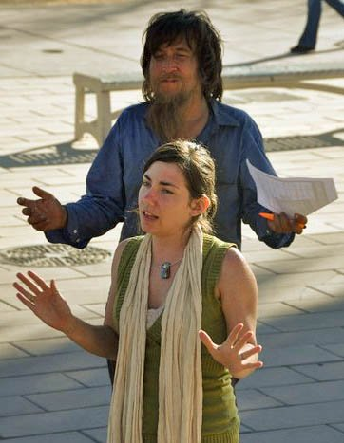
Street Bum Tries to Distract
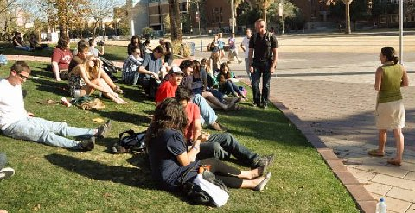
"She (Evangeline) held the attention of the students well."
My last session I spoke on three things that Christianity has to offer: 1. the forgiveness of sins and a clear conscience. 2. Friendship with the Creator of the Universe as well as a Father/son relationship with God. 3. Eternal life.
In the evening our hostess, Judy S., related how God had given her the spirit of intercessory prayer for about two hours in the afternoon, which would have included the time the devil was harassing us with Hell’s bells.
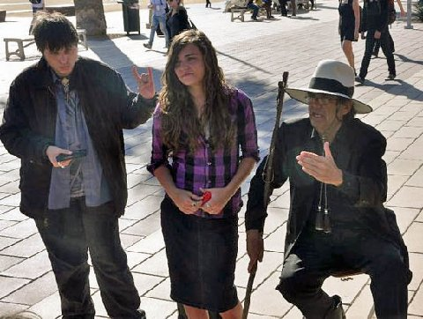
Very Demonic Guy
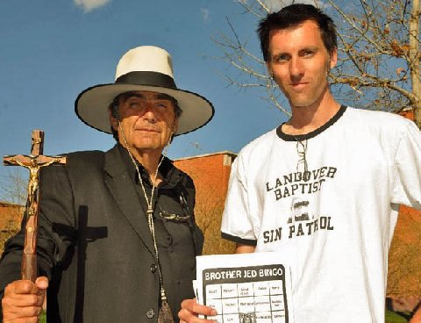
Leader of the Sceptics Club and author of the Bro. Jed Bingo Game
THE FINALE
UA, February 18, 2011
My opening message was from the Apostles’ Creed as “he was crucified, dead and buried. . . The third day he arose from the dead.” The Creed is the best and most succinct statement of faith that I have ever read. It is our statement of faith on our website. I believe it should be the rallying point for Christians of different denominations and traditions. For the first hour the hill was filled with people and I stayed mostly on topic.
At about 12:45, I called upon Martha and Evangeline to stand together since students had asked me, “What do your daughters think of what you do?” I gave the girls the opportunity to speak for themselves. I think it makes for a great testimony for children to affirm the faith, morals and manners of their parents. This is rare among younger generation. The girls answered questions right through the class break. After about 20 minutes, Martha sat down and allowed Evangeline to take over; she spoke for another 30 minutes.

Martha and Evangeline Respond to the Familiar Question, "What do you think of your father?"
Today, God kept the more distractive students like the Broken Record, the music devil and other such base men away. The Skeptics’ Club did not hand out their bingo cards. They were not begging me to tell my stories or sing the gay song.
I spent a considerable amount of time teaching on the rules of Biblical interpretation. One of the frequently asked questions of students is, “How does one know whether a verse of passage is to be taken literally or figuratively?” Students are mistaken in thinking that we Christians take everything in the Bible literally. Taking the Bible too literally is one of the main reasons why they find what they believe are contradictions in the Bible. I explained that some stories in the Bible such as Cain and Able, Abraham and Isaac have both a literal or historical meaning as well as a figurative meeting. Nicodemus erred in taking Jesus literally when he said, “You must be born again.”
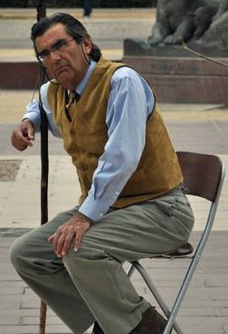
“How does one know whether a verse of passage is to be taken literally or figuratively?”

I taught on Satan and his hope of still overthrowing God by provoking him to act unloving. Satan wants God to fight him on the grounds of hatred and deception. Satan has mastered these techniques of spiritual warfare. He figures that if he succeeds in getting God to fight on evil terms than he can defeat God. Satan is convinced that selfishness, hatred and deception are stronger forces than unselfishness, love and truth. God will prove him wrong in the end; even though for the moment it often seems that that the devil is winning. So it appeared upon when Jesus in apparent weakness was suffering on the Cross. The Church seems often to be losing ground but rest assured that we will win in the end. Our adversary knows his time is short. But no one should think for a moment that Satan is reconciled to his ultimate fate, the Lake of Fire. He still hopes to rule and reign, not just on earth but in heaven too.
I explained how students are always attempting to provoke me to lose my temper and respond unloving. But by the grace of God in four decades of preaching I have never responded unloving (harshly, yes, but always in love). Should I react selfishly or resort to deception in attempting to bear witness of the Truth, I lose the battle and am discredited. From Calvary, in the most maddening of circumstance, Jesus prayed for his enemies when he might have cursed them. Love never fails even though it often appears to be weak.
Our loving God appeared to be weak to Lucifer, which is why he thought he could get away with his original rebellion in heaven. And he looked to be getting away with his revolt for a long time [It would have taken a lengthy amount of time for Lucifer to muster a third of the angels to rebel against God.] Finally, Michael rises up and cast the devil out of heaven. Satan did not give up then, and he is not about to give up now.
Another tactic of the devil is to try to keep the Church on the defensive. When one only fights defensively, he cannot win a war. I explained that Satan has succeeded in putting most Christians on the defensive. They have a problem with me because I am on the offensive and consequently offend most people.
If the Church is defeated, is not God defeated? Is not the Church his body on earth? Will God allow his Church to lose? I think not, has he not promised that, “The Gates of Hell will not prevail against the Church?” We are to be the Church aggressive and militant and the Church triumphant! I have problems with eschatological scenarios which represent the Church as defeated in history. I know that it does not look good currently for the Church. But neither did it bode well in history’s darkest hour with the Messiah, crucified, dead and buried. However, within three days Jesus triumphed over sin, death and Hell. He arose and said, “All power was given unto him in heaven and in earth.” The situation can turn around very quickly.
I had much more to say on these themes today but the above outline should give you an idea of my message.
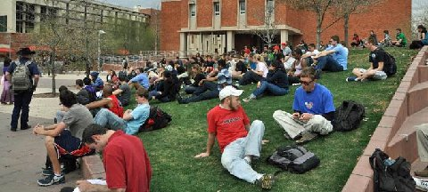
"Evangeline, (far left) is in her element on campus."
Evangeline in her last turn at 4 PM had to take on the student who yesterday was pleading for sin based upon man’s alleged total depravity at birth. Evangeline exposed him as a five point Calvinist. She kept challenging him to defend other points of Calvinism. He said, “Students could not understand the other points.”
It is not unusual that Calvinists are reluctant to talk outside of the confides of their sanctuaries about the other points, especially limited atonement. They also tend to be hesitant to make known their belief in predestination, because they know they are vulnerable in defending this doctrine to skeptics. They will speak of these things among fellow Calvinists, who will not usually ask the difficult questions.
While Evangeline preached, I had the opportunity to have a profitable conversation with the leader of the Skeptics’ Club, Benjamin. He has a humble manner about him and did seem to be listening and considering my arguments. I suggest that his humble manner is a result of his Christian upbringing.
I gave the students a final 15 minute exhortation on seeking the Lord. Then we took a group picture. Also, several students wanted to have their picture taken alone with me. A significant number of students approached me today and thanked me for coming to campus and indicated that they were looking forward to my return. One fellow with a cowboy hat, who demonstrated some hostility earlier in the day, showed an attitude change when he shook hands with me and said, “You have a lot of guts. I am a senior. I have been listening since I was a freshman. You have a lot of courage.”
Roy Spears, who regularly evangelizes at UA, said, “Brother Jed, I received a lot of compliments on your ministry. You are more theological.” Then he stood back and said with a loud voice for everyone to hear, “Brother Jed, You are the man! I could not do what you do. You are a real man.”
I responded, “I am what I am by the grace of God.” And Evangeline, Martha and I walked off into the sunset. I must admit that I love to stand virtually alone against a campus of thousands. I know that ultimately, the heavenly host is behind me. And there be more with me than be with them.
Unfortunately, Evangeline is flying home Saturday night. Pray that the Lord will make a way for her to get on campus more regularly. She is in her element on campus. She can do Q & A as well as anyone I know, although not quite with the flair of her mother. But her answers are always thoughtful and reasonable.
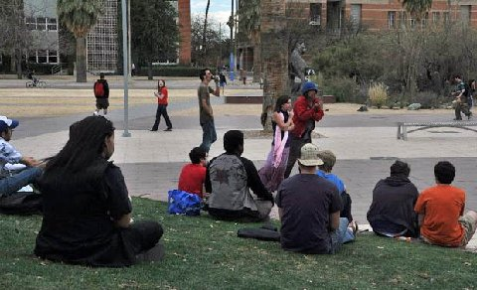
..."She (Evangeline) can do Q & A as well as anyone I know...her answers are always thoughtful and reasonable."
This evening I received the following email:
Dear Brother Jed,
I engaged in conversation with you today at the University of Arizona and I never thought I would say this, but thank you. You answered my questions and treated me with respect, and I sincerely appreciate that. I am battling with my beliefs right now, and I think you were able to shed some good light into my life. I know many of my fellow students make a mockery of what you say but I believe everything you say is in earnest. I appreciate that you care about your fellow man enough to subject yourself to that just to try to get people to turn from their sins. Although we may not see eye to eye, I respect you and wish you well in your journey with Christ. Thank you for reminding me to keep God as the center of my life and my actions.

Sincerely,

Suzie B.

Thank you for your faithful prayers and support. Please continue to pray for us. You may donate to CMUSA using PayPal by going to our web site brojed.org or by mailing your check to our home address: CMUSA 2402 Longview Dr. Columbia, MO 65203. All gifts are tax deductible. Thank you for your generosity.

